Chapter 6 Gases name: class:
1. 掌握理想气体定律 PV = nRT
R = 0.08206 L·atm/mol·K = 62.36 L·mmHg/mol·K = 8.314 J/mol·K
STP: 0°C (273 K), 1 atm; Molar volume at STP = 22.4 L/mol

1. A 2.50 L container holds 0.125 mol O₂ at 298 K. What is the pressure? (R=0.08206) （ ）
A 0.612 atm
B 1.22 atm
C 2.44 atm
D 4.88 atm

2. The container is heated to 373 K. What is the new pressure? （ ）
A 0.98 atm
B 1.22 atm
C 1.53 atm
D 1.83 atm

3. CO₂ is collected over water at 25°C.
Total pressure = 758 mmHg, vapor pressure of water = 23.8 mmHg.
Volume = 1.85 L. (R=62.36)
(a) Calculate the partial pressure of dry CO₂. [1 mark]
(b) Calculate moles of CO₂ collected. [2 marks]
(c) Calculate the mass of CaCO₃ that decomposed. (CaCO₃ = 100.09) [1 mark]

4. For an ideal gas at constant pressure and temperature, which diagram shows the correct graph of pV against n? （ ）
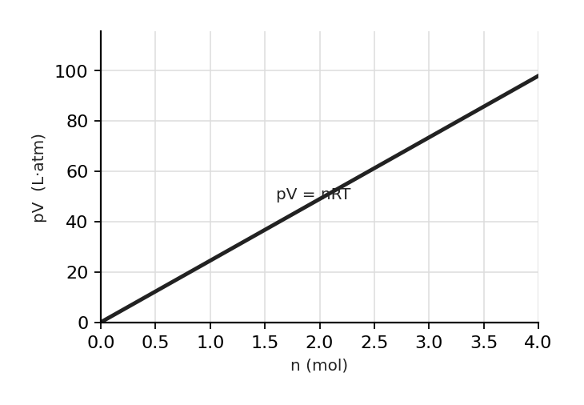
图 C₆-3：恒定 P、T 下理想气体 pV 随 n 变化图（对应第 1 节 MCQ4，pV = nRT，过原点直线）
A. Diagram A — particle arrangement
B. Diagram B — particle arrangement
C. Diagram C — particle arrangement
D. Diagram D — particle arrangement

5. 0.96 g of hydrogen gas is contained in a sealed vessel of volume of 7.0 L at a temperature of 303 K.
What is the pressure of the vessel? （ ）
A. Option A
B. Option B
C. Option C
D. Option D

6. A sample of chlorine gas with a of mass 5.35 g has a volume of 1.25 L at a pressure of 1.00 atm.
What is the temperature of the gas? （ ）
A. Option A⁻³ K
B. Option B
C. Option C
D. Option D

7. A mixture of three gases in a sealed container is able to generate 4.5 atm of pressure.
The identities and amounts of each gas are as follows: 0.3 moles of Cl₂, 0.4 moles of N₂, 0.5 moles of Ar.
What is the partial pressure of nitrogen gas? （ ）
A. Option A
B. Option B
C. Option C
D. Option D

8. A sealed 6.00 L cylinder contains 13.30 g of CO₂ (g) and 17.00 g of Ar (g).
What is the total pressure, in atm, of the gas mixture in the cylinder at 303 K? （ ）
A. Option A
B. Option B
C. Option C
D. Option D

9. The glass containers X and Y are connected by a closed valve. X contains pure CO₂ gas at 298 K and a pressure of 1.00 atm.
Container Y has been evacuated prior to the experiment and has a volume three times bigger than container X.
During the experiment, the valve is opened, and the temperature of the whole apparatus is raised to 433 K.
What is the final pressure in the system? （ ）
A. Option A
B. Option B
C. Option C
D. Option D

10. A sample of bromine and nitrogen gas in a closed container of constant volume is cooled until its absolute temperature is halved.
Which of the following statements is true? （ ）
A. The average speed of the gas molecules remains the same.
B. The number of molecules per L of bromine gas will decrease.
C. The pressure of the gases will halve.
D. The density of the gases will decrease.

11. A gas mixture at equilibrium held over water at 35°C contains 3.0 moles of helium, 5.0 moles of argon, and 2.0 moles of water vapor.
If the total pressure exerted by the gases is 740 mmHg, what is the vapor pressure of water at 35°C? （ ）
A. Option A
B. Option B
C. Option C
D. Option D

12. A 4.5 L container holds ethane gas at 50°C and a pressure of 3.5 atm.
If the temperature is increased to 350°C and the pressure is reduced to 1.5 atm, what is the final volume of the gas? （ ）
A. Option A
B. Option B
C. Option C
D. Option D

2. 掌握动力学分子理论（KMT）
KMT assumptions: (1) particles have negligible volume; (2) no intermolecular forces; (3) elastic collisions; (4) average KE ∝ T
Average KE depends ONLY on temperature: KE = 3/2 RT (per mole)
At same T, lighter gas has higher average speed: v_rms ∝ 1/√M

1. Equal masses of He and Ar are placed in identical containers at the same T. Which exerts greater pressure? （ ）
A He because it has more moles (lower molar mass).
B Ar because it has stronger London forces.
C Both exert the same pressure.
D He because it has greater average KE.

2. At the same temperature, which gas has the highest average particle speed? （ ）
A O₂ (Mr = 32)
B N₂ (Mr = 28)
C NH₃ (Mr = 17)
D CO₂ (Mr = 44)

3. Consider two identical sealed containers containing N₂ (g) at 273 K.
One container contains 1 mol of N₂ (g) and the other 4 mols of N₂ (g).
Which of the following statements is true? （ ）
A. The pressure is greater in vessel 1.
B. The force at which the molecules collide with the walls is greater in vessel 1 than vessel 2.
C. The pressure is the same in each vessel.
D. The average kinetic energy of the molecules is the same in both vessels.

4. The distribution of molecular energies in a sample of a gas at a given temperature is shown by the Boltzmann distribution graph above.
If the temperature is increased, what will happen to the position of point X? （ ）
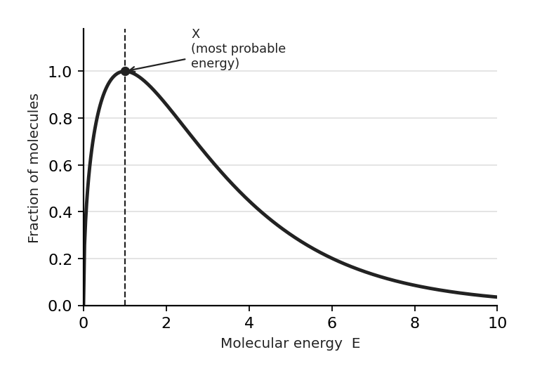
图 C₆-1：分子能量 Boltzmann 分布曲线（对应第 2 节 MCQ4，X 为最概然能量）
A. Fewer molecules possess the most probable energy value so X will shift to the right.
B. Fewer molecules possess the most probable energy value so X will shift to the left.
C. More molecules possess the most probable energy value so X will shift to the left.
D. The position of X will stay the same but the area under the distribution curve increases.

5. 1 L of gas X and 1 L of gas Y are kept at the same temperature and pressure.
The speed of the molecules is plotted against the fraction of molecules with that speed.
What can be deduced about the two gases? （ ）
A. The molar mass of X is larger than the molar mass of Y.
B. The molar mass of Y is larger than the molar mass of X.
C. The average kinetic energy of X is higher than that of Y.
D. The average kinetic energy of Y is higher than that of X.

6. Which graph shows how the average kinetic energy of a gas varies with temperature? （ ）
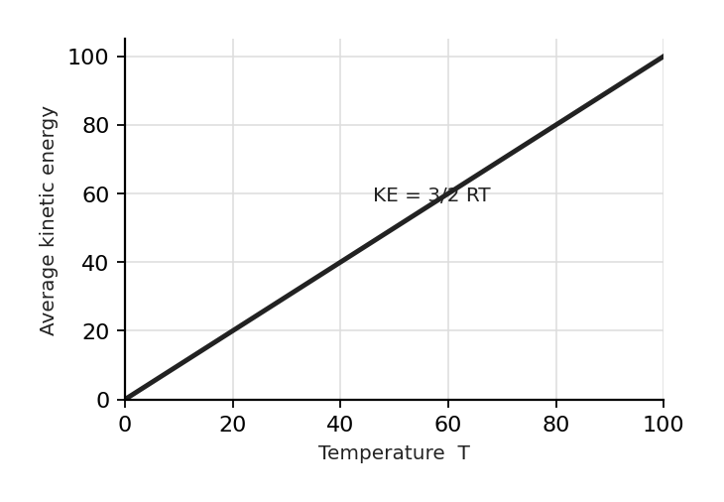
图 C₆-2：平均动能随温度变化图（对应第 2 节 MCQ6，KE = 3/2 RT，过原点直线）
A. Graph A
B. Graph B
C. Graph C
D. Graph D

3. 了解实际气体与理想行为的偏差
Real gases deviate from ideal at: high P (volume of particles significant) and low T (IMF become significant)
Large, polar molecules deviate more than small, nonpolar ones

1. Under which conditions does a real gas behave most like an ideal gas? （ ）
A high P, low T
B high P, high T
C low P, high T
D low P, low T

2. An experiment is conducted to calculate the molar mass of an unknown gas of known mass.
Measurements of pressure, volume and temperature are taken during the experiment.
Which conditions of temperature and pressure would give the most accurate value of molar mass? （ ）
A. low pressure, high tempearture
B. low pressure, low temperature
C. high pressure, high temperature
D. high pressure, low temperature

3. Which of the following best explains why CO₂ deviates from ideal gas behavior at a low temperature and high pressure? （ ）
A. CO₂​ molecules move too quickly to interact with each other
B. CO₂ molecules have significant intermolecular attractions, causing the measured pressure to be lower than predicted
C. The volume of CO₂ molecules becomes negligible
D. CO₂​ collisions with container walls are perfectly elastic, as assumed in ideal gases

